
Subsided by the Making a Difference Campaign

CS & Seniors Christmas Meal
MONDAY 8th

DECEMBER 2025

TIME 7.30PM – 9.00PM

COSMO EDINBURGH

Back by popular demand, Company Section and Seniors Christmas Meal, the perfect way to celebrate the season together – great food, great company, and plenty of festive cheer!
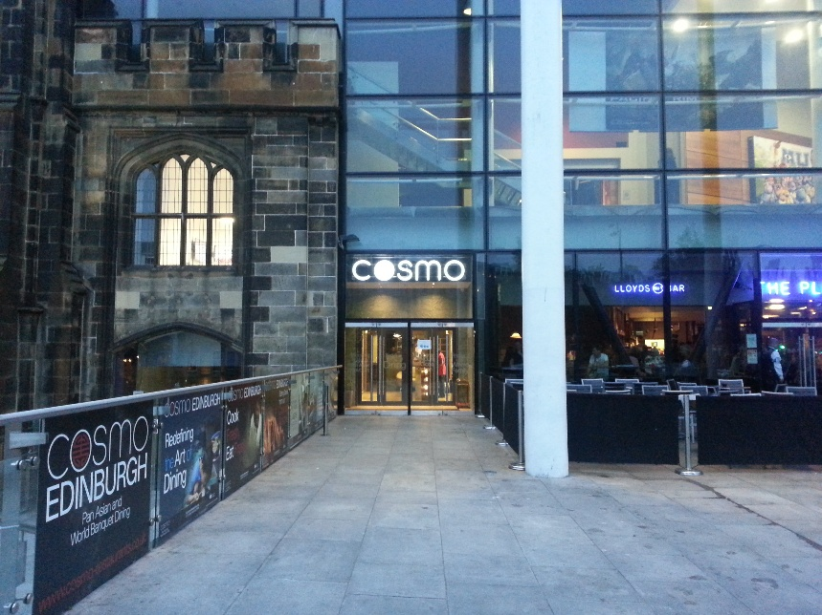
Cost Per Person: £15
(Includes meal and bottomless soft drinks)

Numbers Required by
31st October 2025.

Meal time is 7.30pm – 9pm

Meet up outside venue between 7.20pm – 7.30pm for seating

CS & Seniors Christmas Meal
Cosmo Edinburgh Monday 8th December 2025

Company Name:___________________________________________

Total Number of CS/Seniors ____________________________________

Total Number of Leaders ______________________________________

£ enclosed for entry fee at £15pp / or tick box to be invoiced □
Signed OIC/Leader__________________________________________________________________

