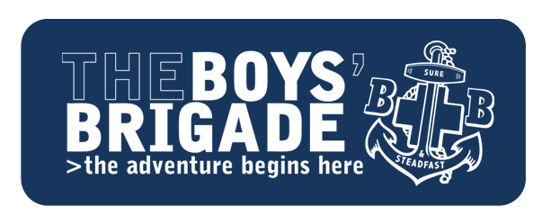

**EDINBURGH, LEITH & DISTRICT TRUST**

**“MAKING A DIFFERENCE” FUNDING APPLICATION**

The “Making a Difference” fund is provided to Companies through the generosity of the Trustees of the 1st Leith (North Leith Parish Church) Company, The Boys’ Brigade asset transfer in 2022.

In return we ask that you share the benefits of this funding within your local community and help to publicise the ongoing excellent work of The Boys’ Brigade Edinburgh, Leith & District Battalion.

**Company Number/Name:**

**Amount Requested: £**

**Reason for “Making a Difference” funding request:**

*(Brief commentary (max 150 words) to support request – i.e., what are the funds to be spent on, how and to whom is it going to make a difference? i.e., our Company members)*

**Contact/requester (Name/position)                                       Date:**

**Bank Account to be credited if approved:  Sort Code:     -     -      Account Number:**

**Send completed form to:** [**finance@thebb-edinburgh.org.uk**](mailto:finance@thebb-edinburgh.org.uk)