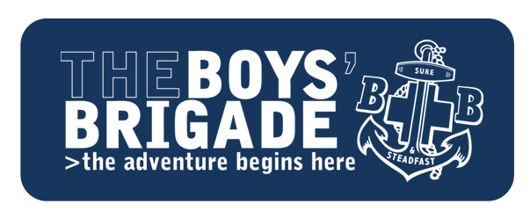

**EDINBURGH, LEITH & DISTRICT BATTALION**

**FUNDING APPLICATION – SESSION 2024/25**

**Company Number/Name:**

**Funding Category (see page 2) e.g. Company Support:**

**Amount Requested:**

**Reason for funding request (brief commentary to support request)**

**Company fundraising (brief commentary on fundraising carried out/planned during this session)**

**Company Funds (approx. value of funds held by Company i.e. Bank Accounts + cash) £**

**Contact/requester (Name/position)                                       Date:**

**Bank Account to be credited if approved:  Sort Code:     -     -      Account Number:**

**Send completed form to:** [**finance@thebb-edinburgh.org.uk**](mailto:finance@thebb-edinburgh.org.uk)

**The Boys’ Brigade - Edinburgh Leith & District Battalion**

**We are fortunate in this Battalion to be in the position of being able to offer financial assistance to Companies in their work from the BB EL&D Trust.**

**I outline the different ways in which we are able to help as below.**

**Company Support:** An Annual amount to assist with the cost of recruitment or other company activity. (Limit of £100 for Session 2023/24)

**Companies’ Special** Financial support for a special project or event which they have

**Projects:** organized or have become involved in supporting

**Training Grants:** 50% cost of all training courses – i.e., Leadership courses/KGVI courses at Carronvale or other national training centres.

**Camp/Holiday:** Where financial assistance is required to allow the boys’ family to meet the cost of camp, funding of 34% is available from the BB EL&D Trust. 33% should be made available from Company funds/fundraising and 33% should be paid by the parent/guardian. Discretion for more assistance from BB EL&D Trust may be available on a need’s basis up to 100% due to severe financial difficulty. *(Note: 34% funding can also apply to Leaders on request)*

**National Events:** Support for attendance at BB National events.

**Brigade Council:** Support for two young officers sponsored by the Battalion to attend brigade council each year.

**Equipment Grants:** To aid companies purchase equipment for company use including Band equipment.

**Uniform:** Discretionary grants to assist Boys to purchase a uniform.

**Transport:** One off grants or assistance with transport for Battalion Events.

**Any Company interested in applying for financial assistance from any of the above funds should contact the Treasurer at HQ with full details via: finance@thebb-edinburgh.org.uk.**

**I will be happy at any time to talk with Officers who feel they require help with any of the**

**above Funds.**

**Simon Porteous, Battalion Treasurer/Trustee**